**Advance Excel Assignment 3**

* 1. **How and when to use the AutoSum command in excel?**

**Ans**: The AutoSum command will sum the integer values given in the closed parenthesis.

Select a cell next to the numbers you want to sum, click AutoSum on the Home tab, press Enter, and you're done. When you click AutoSum, Excel automatically enters a formula (that uses the SUM function) to sum the numbers.

* 1. **What is the shortcut key to perform AutoSum?**

**Ans**: Alt+=

AutoSum is a fast, easy way to add up multiple values in Excel. You can access the AutoSum command from either the Home tab or the Formulas tab, but there is a keyboard shortcut that makes it even faster: Alt+=. To use this shortcut, simply hold down the Alt key, then press the equals sign on your keyboard.

* 1. **How do you get rid of a Formula that omits adjacent cells?**

Answer: Many ways to delete formulas that omit adjacent cells.

* + 1. Select the cell that contains the formula and press the “Delete” button on your keyboard
    2. Select the cell that contains the formula and right-click and select “clear contents” from the context menu
    3. Select the cell that contains the formula and go to the Home tab, in the Editing group, click “Clear All”

* 1. **How do you select non-adjacent cells in Excel 2016?**

**Ans**: Here are 2 ways:

* + 1. Click on the first cell to be selected, press and hold ctrl on your keyboard and click on each additional cell that you want to select
    2. Type cell in Name Box” like A2, C5, D6 to select

* 1. **What happens if you choose a column, hold down the Alt key and press the letters O C W in quick succession?**

**Ans:** If you choose a column in Microsoft Excel, hold down the "Alt" key, and press the letters "O", "C", and "W" in quick succession, the "Column Width" dialog box will be displayed.

This dialog box allows you to change the width of the selected column in terms of the number of characters that can be displayed in the cell.

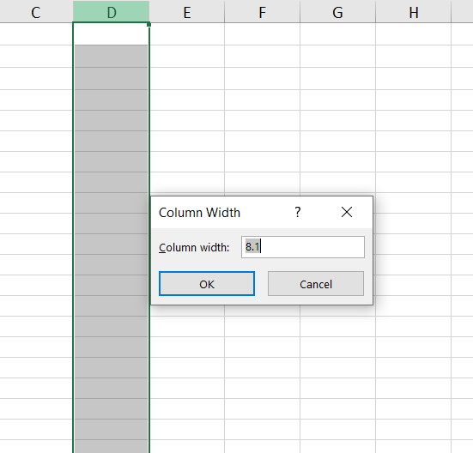

* 1. **If you right-click on a row reference number and click on Insert, where will the row be added?**

**Ans**: If you right-click on a row reference number in Microsoft Excel and click "Insert", a new row will be added above the row that you right-clicked on.

For example, if you right-click on row 4 and click "Insert", a new row will be added to row 4, and all of the rows below row 4 will be shifted down one row. The new row will be blank, and then it can be used to enter data or formulas into it as needed